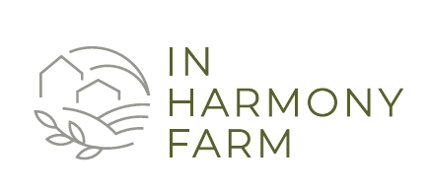

NEW FARMER PROGRAM APPLICATION

The mission at In Harmony Farm, is to work with our farmland and its organic resources to feed our neighbors, demonstrate regenerative agriculture, protect native habitat, and offer meaningful experiences.

Our Farm Program provides opportunities for land access for specialty crop production and new farm and new farm business development. Please complete the application below if you are interested in participating in the program.

Contact Information
Name (First & Last)
Home Address

Phone Number
E-mail Address

Farm Experience
Where was the farm?
How long did you farm there? How many acres did you farm?
What did you grow?

Did you sell your product? YES NO

If yes, where did you sell your product?

Do you have experience running a farm business? YES NO

If yes, please explain:

What farm equipment do you own?

What additional equipment would you need to farm?

Program questions.
How did you hear about the Farm Program?

Why are you interested in the Farm Program?

What produce do you want to grow?

How many acres do you want to farm?

Less than 1 acre | 1 - 2 acres | 2 - 3 acres | 3 - 4 acres | 4 - 5 acres

Do you have a written business plan? YES NO
Do you have a marketing plan? YES NO

Would you please provide a reference of a person that can verify your farm experience and skills?
Name:

Relationship:

Contact Information:

Name:

Relationship:

Contact Information:

List any farm safety classes or training you have completed.

Other information you would like us to know about you and your experience with farming (international farming experience, family history of farming, personal interest in farming, etc.)

I attest to the truthfulness of the information provided in the application and acknowledge that, if accepted into the program, falsifying information is grounds for termination.

Signature: ______________________________________________________Date____________________

